Tagline

*Be a digital transformation driver by delivering innovative solution to the African market*

**Solutions**

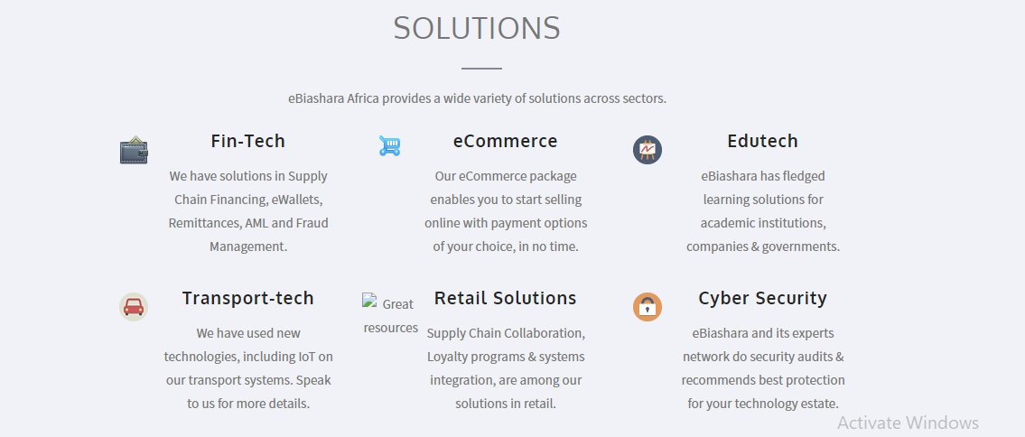

*Change the above to four solutions and with the description listed as below:*

* **Fintech**: Supply Chain Collaboration, Loyalty Programs and Systems Integration are amongst our solutions in Fintech.
* **Cyber Security**: eBiashara and its experts network do security audits, recommends best protection for your technology estate.
* **Cloud Computing**: We are direct partners with Microsoft and First Distribution for AWS. We recommend best practice for cloud computing.

Or

* **Cloud services:** eBiashara provides consulting services for AWS and AZURE , we are direct partners with both and are reselling partners with First Distribution and Liquid Telecom
* **Consultancy services**: Melody/Baiju please add one liner.

**Products**

1. **Supply Chain Collaboration**

SCC handles the full supply chain process from Purchase Order to the approval of invoice. The platform has a unique Quantity & Price settlement process which results to a qualified invoice that can be financed by a Financial Institution.

1. **supplier invoice discounting**

Our solution enables Buyers, Suppliers and the Financier  to share financial documents and necessary approval for invoice discounting . The supplier incurs a small fee to avail instant invoice discounting instead of waiting for the maturity of the invoice.

**OR**

Our web-based Early Payment solution enables Buyer/Supplier to upload invoices with payment at a future date, Suppliers view the receivables, and may choose to request for early payment, less a low financing fee based on the Buyer’s credit rating.

1. **Buyer invoice financing**

Buyer Invoice Financing product enables Buyer and Distributor to improve their working capital by extending the payment terms of their invoices from Sellers/Manufacturers on a centralized technology platform.

**OR**

Our platform provides effective collaboration environment between the seller and the Financial Institution allowing pre-agreed distributors to extend their payment terms in a controlled and automated way.



**We can add our new partners here- AWS, F5, Trendmicro, ecofeel-** where can we get our partner list to be added here?

**CONTACT**

*Change Address as below*

4th Floor Orbit Place,

Chiromo road,

P.O. Box 624-00621 Nairobi, Kenya.  
Email: [info@ebiashara.com](mailto:info@ebiashara.com)

Phone: +254 724 114 111

For regular updates you can follow us :

LinkedIn:

Facebook

Instagram

Twitter

**FAQ’s**